

**DEPARTMENTOFCOMPUTERSCIENCEANDENGINEERING**

ProjectFinalReport

**Project Information:**

ProjectName:***Riko:TheAdventurer*** Course Name: Final Year Project Course Code: CSE-436

**Supervisor:**

Mr.SakhawatHossainSaimon Lecturer

Department of CSE MetropolitanUniversity,Sylhet

**PresentedBy:**

NusratJahanShanta Batch: CSE 34th

IDNo.:143-115-016

Department of CSE MetropolitanUniversity,Sylhet

**Acknowledgement**

First of all, I would like to give thanks to almighty Allah for giving me the opportunity to complete and submit this final year project. Without the help and blessings of Allah the Almighty, it would not have been possible to accomplish the completion of this project.

I would also like to express my gratitude towards my supportive and encouraging project supervisor, **Mr. Sakhawat Hossain Saimon,** Lecturer - Metropolitan University, for his inspiring guidance, reliability, constructive criticism and challenging but motivational feedback throughout the course of this project.

Finally, I would like to thank the Head of the Department, **Mr. Fuad Ahmed**, and **all of the faculty members** of the Department of Computer Science and Engineering, Metropolitan University for equipping me with the skills and knowledge of our field of education required to accomplishthisfinal yearproject.Yourcontributionwilldoubtlesslybeacknowledgedand Iwill always remain grateful to you all.

**Certificate**

Theundersignedherebycertifythattheyhavereadandrecommendthecontrollerofexamination for the acceptance of the project entitled, "Riko: The Adventurer”, by **Nusrat Jahan Shanta**. It has been defended in front of the following members of the project committee in 2019. The members have accepted this project as thepartial fulfillment ofthe requirement for thedegreeof Bachelor of Science in Computer Science and Engineering.

|  |  |
| --- | --- |
| ____________ Project Supervisor  **SakhawatHossain Saimon**  Lecturer  DepartmentofCSE  MetropolitanUniversity,Sylhet | _ _ _ _ _ _ _ _ _ _ _ _ MemberoftheCommittee  **Nazmin Akhter Assistant** Professor DepartmentofCSE  MetropolitanUniversity,Sylhet |
| _ _ _ _ _ _ _ _ _ _ _ _ MemberoftheCommittee **Sharmishtha Dutta**  Lecturer  DepartmentofCSE  MetropolitanUniversity,Sylhet | _ _ _ _ _ _ _ _ _ _ _ _ MemberoftheCommittee **Md. AshikulShakil**  Lecturer  DepartmentofCSE  MetropolitanUniversity,Sylhet |

**DECLARATION**

I, **Nusrat Jahan Shanta**, hereby declare that this project is the record of authentic work carried out by me during the final term of my B.Sc. and has not been submitted to any other University or Institute towards the award of any degree.

**SignatureoftheStudent**

**Abstract**

This report focuses on the development of 2D Top-Down RPG Mobile and Desktop game, Riko: The Adventurer. The project is based on Retro Pixel games containing 4 different dungeons for the player to play. It has multiple achievable and separately upgradeable weapons, player’s experiencegainingsystemwith3differentplayerskins,computercontrolledintelligentenemies

- both Melee and Ranged to challenge the player along with simple NPCs and other interesting objectslikechests,crates.Unlikethetraditional Top-DownRPGgameswhereplayerattackwith sword, this game rather has guns to attack just like Survival Shooting games.

This project explores a new dimension to the traditional Retro Pixel RPG games by mixing the features of Survival Shootinggames whereplayer shoots enemies to survive. With the simplicity of this game it simplyaims to bring fun and make you look back to your childhood’s Roguelike, Pokémon, Mario games with some new modern features.

**TableofContents**

Chapter1 –Introduction 8

* 1. Game Overview 8
     1. Synopsis 8
     2. TargetAudience 8
     3. GameDescription 8
  2. Game Objectives 9
  3. Whygame asaproject? 9
  4. Methodology 9

Chapter2 – FeasibilityStudy 10

* 1. Financial Feasibility 10
  2. TechnicalFeasibility 10
  3. EconomicFeasibility 11
  4. LegalFeasibility 11

Chapter3–SystemDesign 12

* 1. ListofClassesandtheirResponsibilities: 12
  2. Class Diagram 14
     1. Data Loading/SavingClassDiagram 15
     2. CollidableClass Diagram 16
     3. PlayerWeaponClassDiagram 16
     4. UserInputClassDiagram 17
     5. FighterClassDiagram 17

Chapter4–Characters,Weapons&Other Objects 18

* 1. MainCharacter 18
  2. EnemyCharacters 18
  3. NPC Characters 20
  4. PlayerWeapons 20
  5. OtherObjects 21
     1. Chest,HealingFountain,Crate 21
     2. ScenePortals 22

Chapter5– LevelDesign 23

* 1. MenuScene 23
  2. Dungeon_1Scene 24
  3. Dungeon_2 Scene 24
  4. Dungeon_3 Scene 25
  5. Dungeon_4 Scene 25

Chapter6–GameDesign 26

* 1. Game Rules 26
  2. Game Structure 26
  3. GamePlay 27
  4. Camera 28
     1. MenuCamera 28
     2. Game Camera 28
  5. HUD 28
  6. Animation States 29
     1. Player 29
     2. Enemies 29
     3. NPCs 29
     4. Environment 29
     5. UI 30
  7. Audio 30
  8. Attemptstomakegamemorefun 31

Chapter7–UserInterface 33

* 1. :Select orUnlock CharacterSkin Menuin Main Menu 33
  2. :CharacterMenuinGameScenes 33
  3. : PauseMenu 34
  4. :DeathMenu 34
  5. NPCDialogue Box 34

Chapter8 – Conclusion 35

* 1. FuturePlans 35

Bibliography 36

# Chapter1–Introduction

This report describes the process involved in making a 2D Top-Down RPG game, Riko: The Adventurer with Unity3D. This game is for both PC Standalone and Android devices. This chapter discusses the game overview including the synopsis, target audience, description, then focuses on the game design, describing how the game is implemented.

## Game Overview

My App is a Multi-Game App which currently contain Rock Paper Scissors and a Space Shooter Game. The Rock Paper Scissors is a 2d game in which players can connect locally and playe among themselves. The Shooter is an action based shooter game where the main objective of the game is to dodge and shoot the enemy spaceships. Pygame is used to look at the designing aspect of the game. Python is the coding language used to give the physics and mechanic concepts. Each aspect of game programming takes a lot of time to master. The objective I hope to deliver by this project is to make a game that has equal amount of designing as well as coding further to strike the perfect balance between the two, So that the game does not feel more physical mundane as well as does not feel jittery in terms of look and feel.

### Synopsis

Two space ships, each fighting to protect their galaxies. One must defeat the other, else their entire galaxy will be enslaved! When these two face-off in the ethereal void, who will win?

### Target Audience

Local multiplayer games was once a trend, slowly died out with the coming of internet and the human urge for worldwide connectivity. There is no proper media, in which people can locally connect and play various games from a single app. This shows that a large base of players are interested in this genre but is not delivered the proper app which connects all such games and gives me a good opportunity to tap into that market by following the traditions that have already set for this genre while working on implementing all such games in a single app.

But I’m mainly targeting to casual gamer between the age range of 13- 18 and 35+.

### App Description

This App involves two players playing against each other. The Rock Paper Scissors game has a health based approach in which each items thrown by the opponents deduct a specific health from the player (i.e., only when the opponent wins the round) . There is when the health reaches zero, the player loses. The shooter game has also similar health based approach. There is also a limit to the number of bullets a player can fire at a time.

## Game Objectives

The major objectives of this game project are:

* To create a Multi-game app which has acces to some traditional multiplayer games.
* To implement health system for Rock Paper Scissors instead of the usual score based system.
* To implement different attack power to rock, paper and scissors.
* To add sound effects to shooting, collisions, etc.
* To design a app in which it is easy to navigate between games and does not require users to put extra time into understanding the functioning of the app.
* To make a User friendly app that is pleasant to look at.
* To code the server for the local multiplayer game.
* To implement a login screen for the players.
* To implement proper file handling to take care of the user’s name password and game statistics.

## Why game as a project?

Video games are not just any computer software which are made to benefit user’s daily life, games are rather made for user’s entertainment purpose, so more than anything we need to pay attention to what the user wants from the game, how to make it more entertaining, just making any game will not do, that is why it’s more challenging because I always have to carefully consider if I’m making developing it correctly to entertain users. I also have to invest a lot of time on the proper game designing to make it visually accepted. And to add that game requires a lot of codes. Each part of the code is like blocks of puzzle which has to put together for the proper functioning of the game. Thus I think game is a perfect project to prove myself as a Computer Science student.

## Methodology

The software methodology I have used to develop this game is Agile methodology which is an approach for developing products (in this case: **games**) using short iterations. The main idea is not making the whole project from start to finish, but making small features for the current project in small periods of time. In this way the results of each iteration are used to adjust the project plan.

* Each iteration are small game parts.
* Self-organizing teams generate the most value.
* Regularly reflect and adjust your way of work to boost effectiveness.
* Welcome changing requirements, even late in the project.

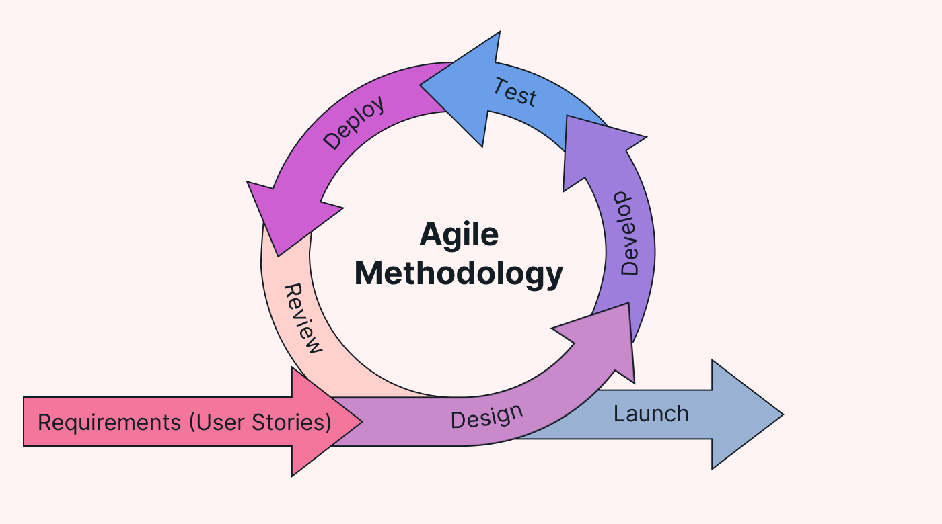

# Chapter2–Feasibility Study

This chapter describes all the feasibilities that come as questions to both the developers and other users during the development of software. The chapter contains financial feasibility, technical feasibility, economic feasibility and legal feasibility.

## FinancialFeasibility

GamePort is a local multiplayer game so there is no hosting cost, if it developed to be a web game, it will only consume internet data.

If it is developed to online game, it can be hosted in my home server which is already running.

If it is developed to a web game, it can be hosted through my domain, so there is no extra money to be spend.

The points mentioned above indicate that the project is financially feasible.

## TechnicalFeasibility

The tools and technology that were used in the making of the GamePort are:

**Game Library:** Pygame

**Image Editor:** Adobe Photoshop CC 2023 Adobe Illtustrator CC 2019

**CodeEditor:** IDLE Python **Programming Language:** Python

These mentioned above technologies are completely free for students. There were no other additional tools required to make this game. Most of my time to develop the game was invested in the code editor, IDLE Python.

The simplicity of the project along with the facts mentioned above proves that this software is also technically feasible.

## Economic Feasibility

The resources that are required for this project are:

* + - Development machine.Any regular laptop/PC with a Minimum Ram of 4GB anda decent GPU can be used for the development of this game.
    - Technical tools and software. As mentioned previously, the tools needed to develop this software are available to developers at no charge.

For now I have used free assets to design the game, if I want to release the game for monetizing purposes this project will also require graphic designers for the game to get proper recognition. As these resources are largely free of cost, the only expenses lie in the payment of the machine. Neither of these is scarce in availability nor are they extremely expensive.

## LegalFeasibility

**The Current License Status**

This project is currently unpublished and intended solely for personal use and educational purposes. As such, it does not require a formal license at this time, as it is not distributed or used commercially.

**Planned Approach for distribution**

In the event that the game is prepared for publication or distribution, appropriate legal steps will be taken. This includes selecting a license to govern use and distribution, ensuring compliance with open-source or proprietary guidelines, and reviewing third-party asset licenses.

**Third party assets**

All third-party assets used in the project (e.g., sound effects, images) are documented and sourced from legally compliant resources, such as royalty-free libraries. Upon any potential publication, further checks on asset licenses will be conducted to ensure full compliance.

**Disclaimer**  
The game is currently in a prototype phase, without any license for distribution or commercial use. Future changes in licensing will be considered and documented as needed.

# Chapter3–SystemDesign

## ListofClassesandtheir Responsibilities:

|  |  |  |
| --- | --- | --- |
| Number | ClassName | Responsibility |
| 1 | AudioController.cs | Responsibletoplayandshufflebackgroundmusic,  playvarioussound effects. |
| 2 | BossOneEyed.cs | Isonekind ofEnemy,whichhasuniqueplayer  attackingfunctionalitythantheotherenemies |
| 3 | Bullet.cs | Movestheplayerbullet,damageenemy,ifithitsthe  wallthen explode. |
| 4 | CameraController.cs | Followtheplayer. |
| 5 | CameraShake.cs | Shakethecamerawhenshooting |
| 6 | Cannon.cs | IsonetypeofGuntoshootbulletsandchildof  Weapon.cs |
| 7 | CharacterMenu.cs | Ispartof UI, responsibletoshowplayer’s currentstats,  managingtheingame system. |
| 8 | CharacterSelectionCamera.cs | IsonlypartoftheMainMenuscenethatfollowsthe  specific player which MenuController.cs sends, showing zoom in, zoom out animations. |
| 9 | CharacterSelectionPlayer | IsonlypartoftheMainMenuscenewhichmovesthe  playerandchangeplayer’sanimationstate. |
| 10 | Chest.cs | Granttheplayereithergoldorweapons |
| 11 | Collectable.cs | IschildclassofCollidable.cswhichissameas  collidableobjectsbutonlywascreatedtomanagetrigger gameObjects like chests. |
| 12 | Collidable.cs | Istheparentclassofallthecollidableobjectsthatcan  comeincontactwitheachother. |
| 13 | Crate.cs | IsachildclassofCollidable.csthatdestroyscrate  whenitcomesincontactwiththebullet. |
| 14 | Damage.cs | Islikestructonlycontains3variables(origin,  damageAmount,pushForce). |
| 15 | DataController.cs | Ithasthefunctionstoloadandsavegame. |
| 16 | Enemy.cs | Is a child class of Mover.cs which is responsible to move the melee enemy, change its animation state, manipulatingitshealthbar,andcontrolsreceive  damagesystemanddeathflow. |
| 17 | EnemyActivator.cs | Responsible to activate the first enemy batch, opening newgateforplayertoattackat,whenplayerkillsall  theenemiesintheassigned area. |
| 18 | EnemyBatchHandler | Contains the list of enemies of the assigned area player can attack, is also responsible to send the closestenemytargetfromitslisttoplayersothatplayercan  auto target, is also responsible to activate the next enemy batch. |
| 19 | EnemyHitBox.cs | Ispartofmeleeenemiesandresponsibleattackthe player |
| 20 | EnemyProjectile.cs | Movestheenemybullet,damageplayer,ifithitsthe |

|  |  |  |
| --- | --- | --- |
|  |  | wallthen explode. |
| 21 | EnemyRanged.cs | Is a child class of Mover.cs which is responsible to move the ranged enemy, change its animation state, manipulatingitshealthbar,andcontrolsreceive  damagesystemsddeath flow. |
| 22 | EnemyShoot.cs | Contains several types of enemybullet movements that be used in ranged enemies to attack the player. |
| 23 | EnemyTargetController.cs | Is a child class of Collidable.cs which simply informs theenemiesiftheplayer isintheirinhabitantsor not,if itistheenemiescanattackorelsemovetotheoriginal  position |
| 24 | EventCallerMobile.cs | Containsfunctionstoswitchweapon,attackenemiesin  mobiledevices. |
| 25 | EventCallerPC.cs | Containsfunctionstoswitchweapon,attackenemiesin  mobiledevices. |
| 26 | EventEnableManager.cs | Detectswhich deviceisthegameis beingplayed,ifthe  deviceisandroiditshowsthemobileHUD(likemobile joysticks, buttons), else hides the mobile UI. |
| 27 | Fighter.cs | Its sole child Mover.cs which is the parent class of all the enemies and the player so technically all of themareactuallyfighters.Itcontainsoverridablefunctions  Death(),ReceiveDamage(Damagedmg). |
| 28 | FloatingJoystick | IsachildclassofJoystick.csanditresponsibleto  movethejoysticktothepositionandithandle’s position according to the gesture. |
| 29 | FlameThrower.cs | IsonetypeofGuntoshootbulletsandchildof  Weapon.cs |
| 30 | FloatingText.cs | Responsibletomovethefloatingtextsandhideitafter  thespecifiedtime interval. |
| 31 | FloatingTextManager.cs | Keepsthefloatingtextstotheminimumamountwhich  isslightlyhelpfultooptimizeperformance. |
| 32 | Joystick.cs | Containsthefunctionstomovethemobilevirtualjoystick,senddirections,valuesofhorizontal,vertical  totheplayer. |
| 33 | GameData.cs | Itcontainsthedatathatisrequiredtobesaved. |
| 34 | GameManager.cs | It is responsible for various activities like loading the game, saving the game, switch weapons, upgrading weapon, unlocking new skin, giving reference of the playertoenemiesandotherobjectsplayerclass,  showingpopuptextetc. |
| 35 | GunSpriteChanger | Justcontainsreferencesoftheplayer’sgunsprites (Images)anditsspawnpointforthebulletto  instantiatewhenplayershoots. |
| 36 | HealingFountain | Healstheplayerwhencomein contact. |
| 37 | Laser.cs | IsonetypeofGuntoshootbulletsandchildclassof  Weapon.cs |
| 38 | Matter.cs | IsonetypeofGuntoshootbulletsandchildclassof  Weapon.cs |
| 39 | MenuController.cs | Itisresponsibleforvariousactivitiessuchas  playerselection,givingreferenceoftheselectedplayer |

|  |  |  |
| --- | --- | --- |
|  |  | totheCamera,UItransitionanimations,skinunlock,  quittinggame etc. |
| 40 | MG.cs | IsonetypeofGuntoshootenemiesandchildof  Weapon.cs |
| 41 | Mover.cs | Is the child class of Fighter.cs, and contains the overridable functions like UpdateMotor(Vector3 input) tomovethecharacters,Animate(floatx)toanimate  them |
| 42 | NPCSpeechTracker | ShowsdialogueboxwithdialogueandNPC’savatar  whenplayercomesincontact. |
| 43 | OpenGateInMenu | IsresponsibletoopenthedoorinMenuScenewhen  playercomesnearit. |
| 44 | Pistol.cs | IsonetypeofGuntoshootbulletsandchildclass of  Weapon.cs |
| 45 | Player.cs | Is a child class of Fighter.csand responsible to move theplayer,changeanimationstate,firingbullets,  receivedamage,settingplayer’shealthetc |
| 46 | Rocket.cs | Isonetypeof Guntoshootbulletsandchildof  Weapon.cs |
| 47 | ScenePortal.cs | Isresponsibletoteleporttheplayertodifferent  dungeons |
| 48 | ShotGun.cs | IsonetypeofGuntoshootbulletsandchildclass of  Weapon.cs |
| 49 | Spazer.cs | IsonetypeofGuntoshootbulletsandchildclass of  Weapon.cs |

Table1:Listofclassesandtheir responsibilities

* 1. **Class Diagram**

Because of so many classes are involved as shown above it is impossible to put all of them in a single A4 page so I have separated the class diagrams that are the core mechanics into separate subsections to show their relations according the system I have designed.

### DataLoading/SavingClassDiagram

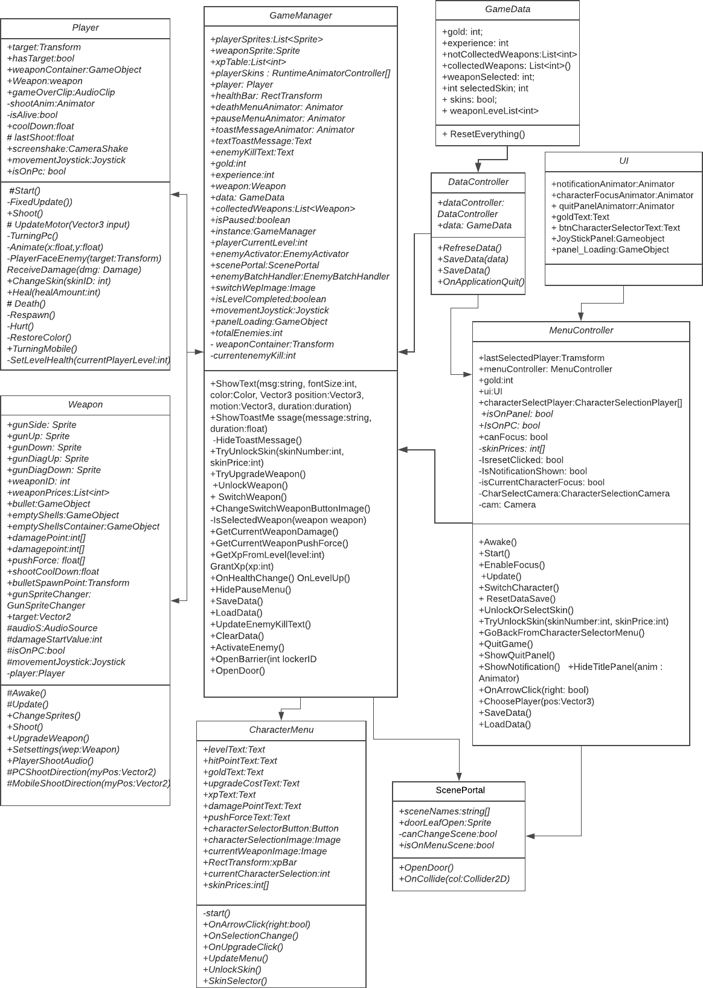

Figure1:Data Loading/SavingClassDiagram

### CollidableClassDiagram

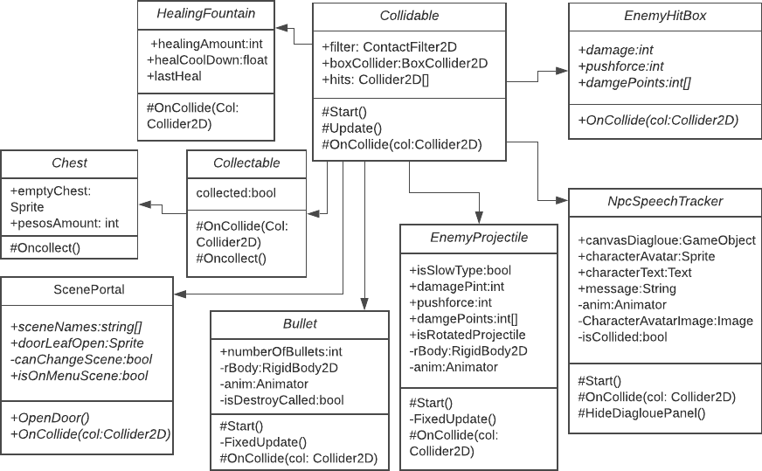

Figure2: CollidableClass Diagram

### PlayerWeaponClassDiagram

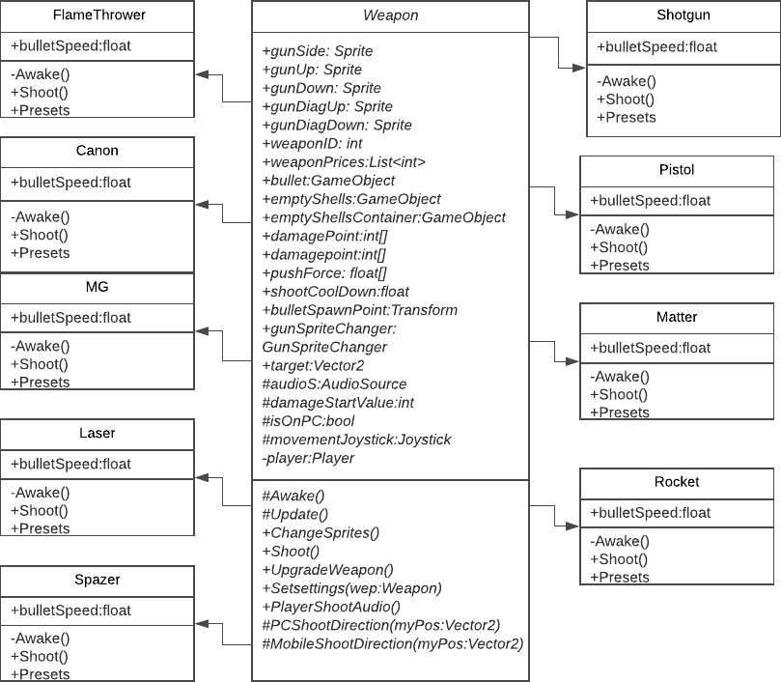

Figure3:Player WeaponClass Diagram

### UserInputClassDiagram

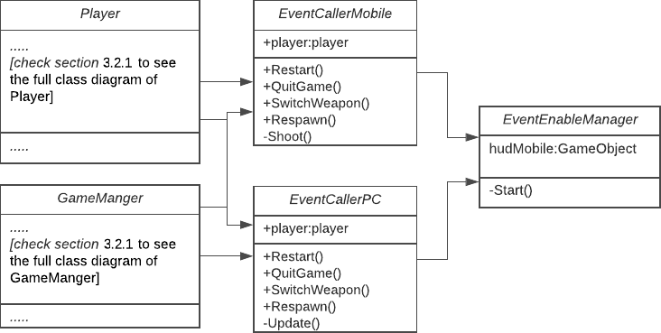

Figure4:Player WeaponClass Diagram

### FighterClassDiagram

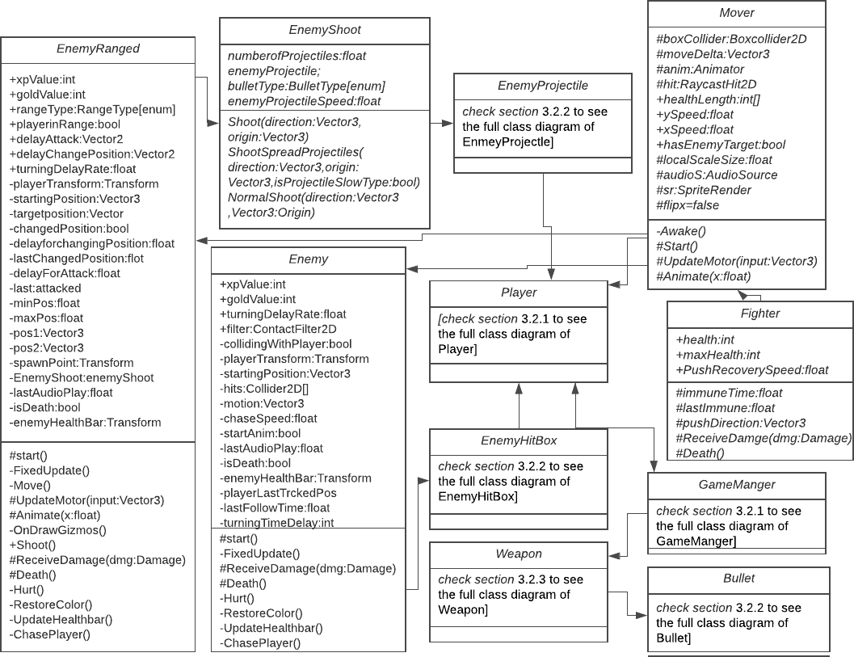

Figure5:FighterClassDiagram

# Chapter4–Characters,Weapons&OtherObjects

Thisisoneoftheinterestingchaptersthat youmayreadwithenthusiasm,becauseitcontains lots of colorful figures. This chapter discusses about the characters: main character, enemies, NPCS and finally other objects like chests, gates, doors.

## MainCharacter

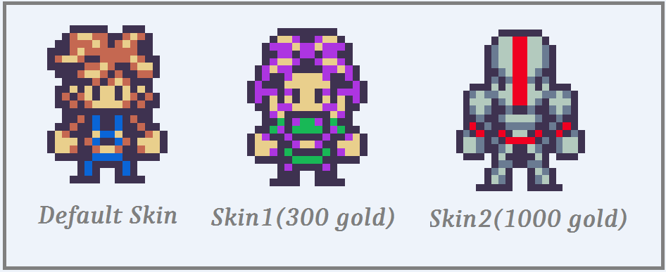

Figure6:Main Character

Theabovecharactersarebeingusedinthegamefortheplayer,thedefaultskin doesnotcostany gold to acquire the skin but otherskins arelocked and the user need purchase them from in game shop with the gold the player collected.

## EnemyCharacters

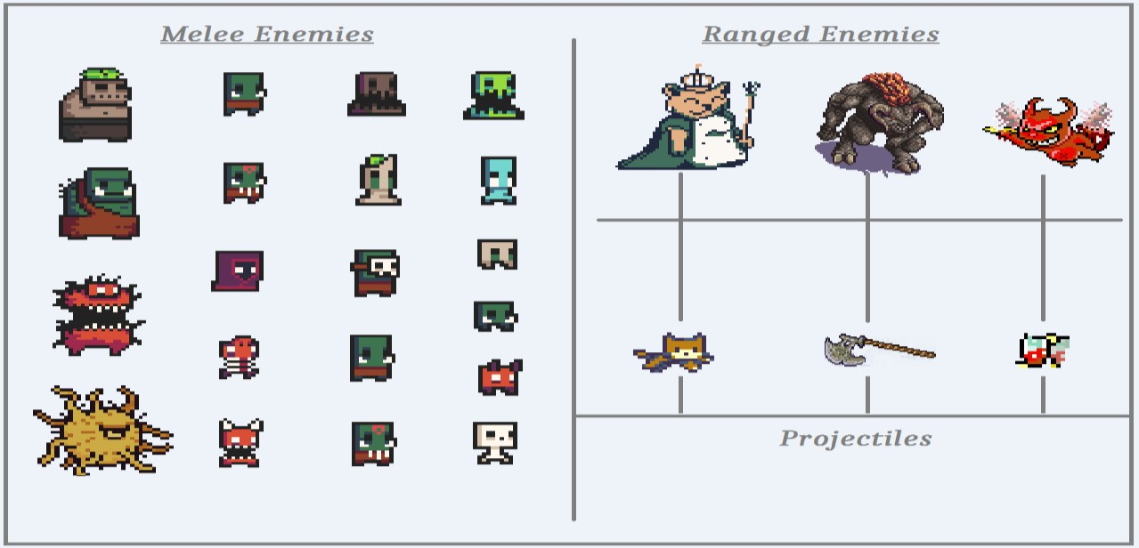

Figure7: EnemyCharacters

Wehavethe followingtwo types of enemies:

* **Ranged:**Rangedenemiesdon’tchasetheplayer,butcanshootsingleormultiple projectiles and only move in either horizontal or vertical direction.
* **Melee:**Meleeenemieschaseandattacktheplayertilltheplayergooutoftheirinhabitant area.

There are total 21 enemies in the game for now, each have different animations, health, damage to challenge the player. The following tables shows the list of enemies with their directional speed, health, damage, xp value, gold value.

|  |  |  |  |  |  |  |
| --- | --- | --- | --- | --- | --- | --- |
| No. | Name | Type | DirectionalSpeed  (x, y) | Health | Damage  Point | Xp Value,  GoldValue |
| 1 | BigDemon | Melee | 1, 0.8 | 40 | 3 | 10,20 |
| 2 | BigZombie | Melee | 0.85, 0.65 | 40 | 3 | 10, 20 |
| 3 | BittenVonKrumpen | Ranged | 0.75 | 20 | 3 pershot | 3, 20 |
| 4 | Devil | Ranged | 0.75-Onedirection | 30 | 2 pershot | 5, 20 |
| 5 | Chort | Melee | 1, 0.75 | 10 | 3 | 3, 15 |
| 6 | Imp | Melee | 1, 0.8 | 10 | 1 | 2, 10 |
| 7 | MaskedOrc | Melee | 1, 0.75 | 15 | 2 | 3, 15 |
| 8 | Minotaur | Ranged | 0.7-Onedirection | 30 | 2 pershot | 3, 20 |
| 9 | Muddy | Melee | 0.5, 0.7 | 15 | 1 | 2, 10 |
| 10 | IceZombie | Melee | 0.9, 0.7 | 15 | 1 | 2, 10 |
| 11 | Ogre | Melee | 0.85, 0.75 | 35 | 3 | 10, 20 |
| 12 | OneEye | Melee | 0.9, 0.75 | 40 | 3 + extra  damage(1) | 10,15 |
| 13 | Orc Shaman | Melee | 0.95, 0.75 | 15 | 3 | 4, 15 |
| 14 | OrcWarrior | Melee | 0.88, 0.75 | 15 | 3 | 3, 15 |
| 15 | Slime | Melee | 0.8, 0.7 | 12 | 1 | 3, 10 |
| 16 | Skelet | Melee | 0.9, 0.7 | 10 | 1 | 2, 10 |
| 17 | Swampy | Melee | 0.8, 0.65 | 10 | 1 | 2, 10 |
| 18 | TinyZombie | Melee | 0.9, 0.7 | 10 | 1 |  |
| 19 | Wogol | Melee | 0.8, 0.65 | 10 | 2 | 3,10 |
| 20 | Zombie | Melee | 0.85, 0.75 | 12 | 2 | 3, 15 |
| 21 | NecroMancer | Melee | 0.95, 0.75 | 15 | 3 | 4,15 |

Table2:ListofEnemieswithStats

## NPCCharacters

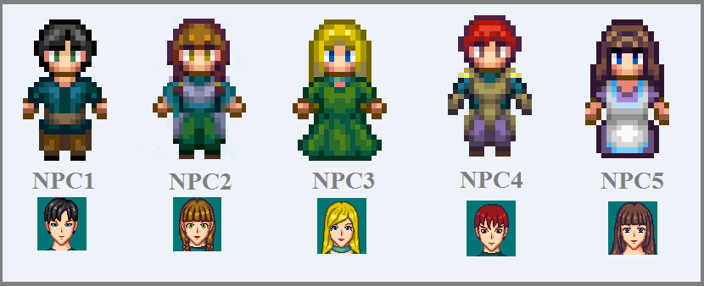

Figure8:NPC Characters

The NPCs above contain the characters alongwith its avatars which pops up with dialogue when player interacts with the NPC. The dialogue system is simple just like other light RPG games.

## PlayerWeapons

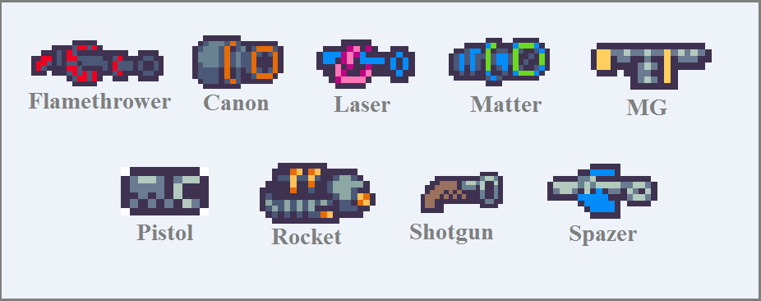

Figure9:PlayerWeapons

There are total 9 guns, except Flamethrower all other guns are locked and can be acquired from chests. And theorder is randomized. Theycan be upgraded individuallyfrom thecharacter shop, each have different sounds effect and bullet to distinguish with different bullet speed.

Thefollowingtableshows the listof all weaponswith their firespeed, short desctiption.

|  |  |  |  |  |
| --- | --- | --- | --- | --- |
| Number | Name | Firing Speed | DamagePer  Shot(before upgrade) | Description |
| 1 | Canon | 3.5 | 2 | Shootsaorangecoloredcannon ball. |
| 2 | FlameThrower | 2.5 | 1 | Shootsaredcoloredbullet. |
| 3 | Laser | 2 | 2 | Shootsasmallpinkcoloredbulletthathas  mediumspeed. |
| 4 | Matter | 1 | 1 | Shootsagreencoloredbulletthathas  slowest speed. |
| 5 | MG | 3.5 | 3 | Shootsayellow colored |
| 6 | Pistol | 4.5 | 1 | Shootsayellowcoloredbulletandisone  ofthecomparativelyfasterbullet. |
| 7 | Rocket | 4 | 4 | Shootsblack-whitebigrocketbulletsand  isoneofthecomparativelyfaster bullet. |
| 8 | Shotgun | 3 | 1 x 3 | Shootsthreewhitecoloredbulletsat the  sametime. |
| 9 | Spazer | 6 | 2 | Shootsabluecoloredbulletthathasthe  fastestspeed. |

Table3:ListofWeapons withStats

## OtherObjects

Thissectionelaboratestheobjects whichplayercancomein contactandaneventmayoccur.

## Chest,HealingFountain,Crate

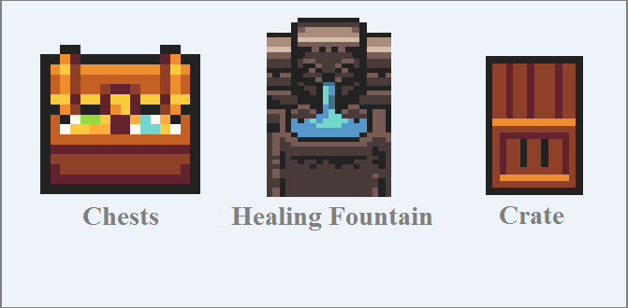

Figure10:Chest,HealingFountain,Crate

Theaboveobjects dothefollowingactivities whenplayer comeincontact:

* + - * Chest: Grants reward to the player either it willbe weapon or gold the first time playercome in contact. If player collected all weapons already it will reward only gold.
      * HealingFountain:Heals playersthemissinghealth
      * Crate:Itdoesnotdoanythingwhenplayercomeincontactbutitisanobstacleand player can destroy it when come in contact

## ScenePortals

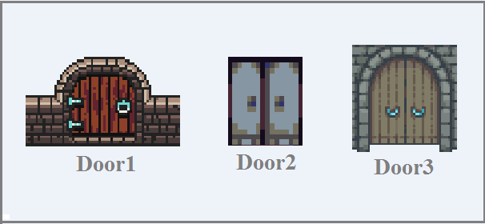

Figure11: ScenePortals

The above doors are used as scene portals to teleport the player to dungeons. The doors simply open if player completes the level or if player is ready to enter the battlefield from the menu scene.

# Chapter5–LevelDesign

Assaid beforeIhavedesigned for dungeons for the game usingthe followingAtlas:

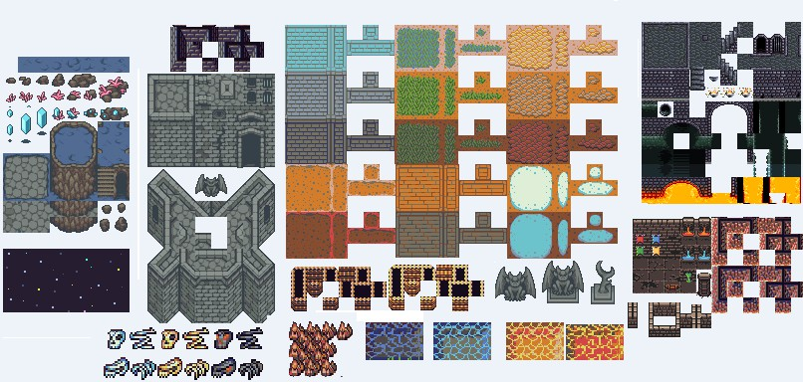

Figure12: LevelTiles

Andmyleveldesignsarethefollowingwithcollidersthem.Thegreenboxesyouwillseeinthe below are the 2D box colliders which ensures that player/enemies stays within the game level.

## Menu Scene

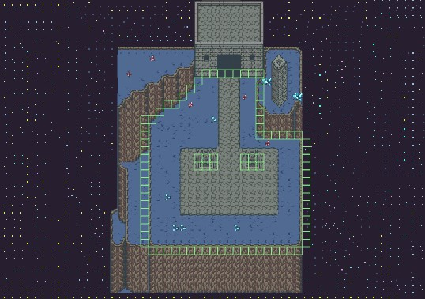

Figure13:MenuScene LevelDesign

## Dungeon_1Scene

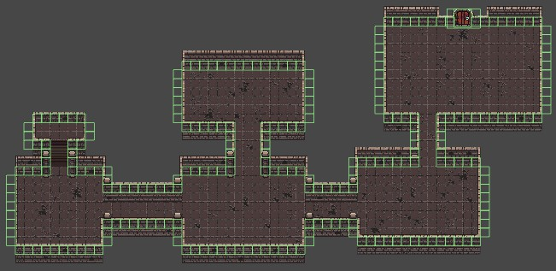

Figure14:Dungeon_1Scene LevelDesign

## Dungeon_2Scene

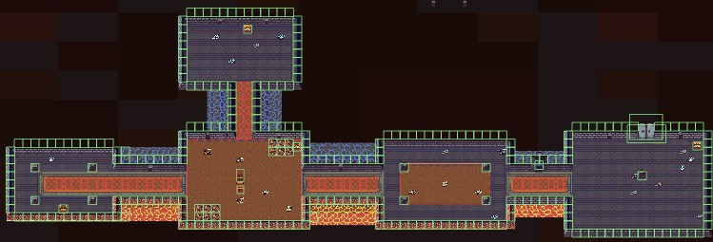

Figure15:Dungeon_2SceneLevelDesign

## Dungeon_3Scene

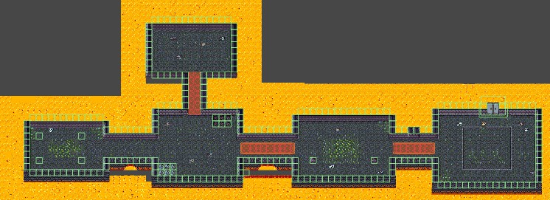

Figure16:Dungeon_3SceneLevelDesign

## Dungeon_4Scene

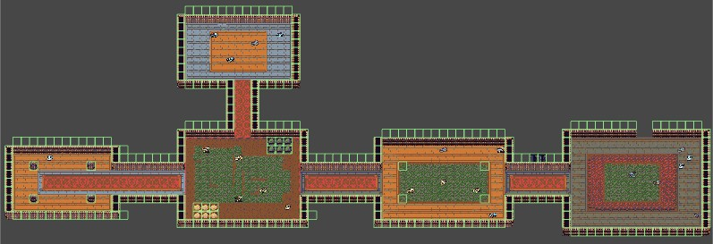

Figure17:Dungeon_4SceneLevelDesign

Therearealsoanimationsinvolvedindesigningthelevellikewater,lavaflowanimationsbut that will be described in the Game Design Chapter.

# Chapter6–GameDesign

Game design is the study of how to make the game functional by setting game rules, game mechanics, gameplay which I already briefly discussed in Chapter 1 but now I will go through them thoroughly. I will also discuss more about what I did to make the game more fun ratherthan visually accepted with the existing resources I have and that is part of game design because even if we make a fancy gamewith good graphical work if the gamedesign is not well enough it will not attract the user. So I invested a lot of time on doing this section, since without it thegame is incomplete.

## GameRules

The game starts with player entering the menu scene where player can select a character, he can also unlock skin during selection if wish, in menu scene the player can move around freely until he wishes to enter the dungeon. In the dungeons the player can also move freely around, shoot bullets and switch weapons if he has more than one. There are multiple enemies inhabiting with different damage points and health that will attack the player if it enters in their inhabitant area. Initially player has no target so he can freely shoot but when player goes near to any kind of enemies the weapon locks the target so player can only shoot it when triggering the shooting event. If player successfully kills the enemy it gains experience points, in the process if experience is max to current grade of the player, the player gets promoted with gaining back the fullhealthandthelevelonlycompletesifhekilledalltheenemies. Thelevelsarealsofilledwith chests in random places which can grant the player gold or new weapons.In games scenes there is also NPCS that player can communicate with.

## GameStructure

QuitScreen

Character Selection

Gameplay(inRandom

Dungeon)

ChooseCharacter

Screen

DoorOpenedtoteleport(ifall

enemiesdied)

LosingSreen(ifDied)

PauseScren

ShopScreen

Figure18: Game Structure

## GamePlay

The following figures illustrates the inputs to control the player. For PC we are using keyboard keys to move the player and mouse to shoot and switch weapons. For mobile we are usingmobile joystick touch inputs and 2 separate buttons for shooting and switching weapon.

* 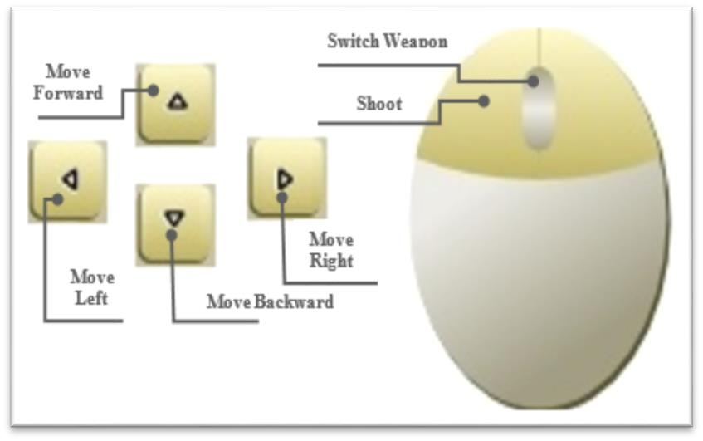**GameControls(PC)**

**MoveBackward**

Figure19: PCKeyboardInputs

* **GameControls (Android)**

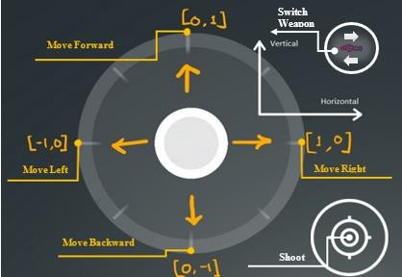

Figure20:Mobilejoysticktouchandbutton inputs

## Camera:

### MenuCamera

At the start of the game on menu scene if the player touches on the screen the camera zooms into the available character skins. If anyof the player skin is touched it simplyzooms in again and ChooseCharacterScreen is shown, after selection and going back from the ChooseCharacterScreen thecamera zooms out and locked its screen to selectedskin for playerto player and follows the player.

### GameCamera

Game camera does not have the fancy zoom in, zoom out effect like menu camera but it follows the player more smoothly and additionally has another script attached to itself to shake camera when player is shooting- this feature is also part ofAttempts toMake the Game More Fun which is the last (6.8) section of this chapter.

## HUD

* **HUD (Android)**

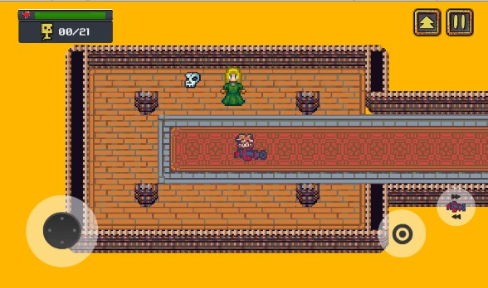

Figure21: HUD (Android)

* 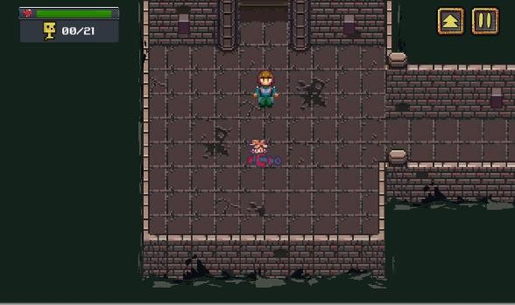**HUD(PC)**

Figure22: HUD (PC)

The HUD for both platforms are pretty much same the only thing that differs is on android devices we need virtual joystick to move, and buttons to shoot and switch weapon, thus we have them and in PC it is not needed.

## AnimationStates

### Player

The player has a total of 5 running animation states: player_side, player_up, player_down, player_sideUp, player_sideDown, this is 8 directional movement. According to the direction of the player looking at the state changes. If the player has weapon, its position also changes according to the player’s states. The following image illustrates the idea of 8 directional movement:

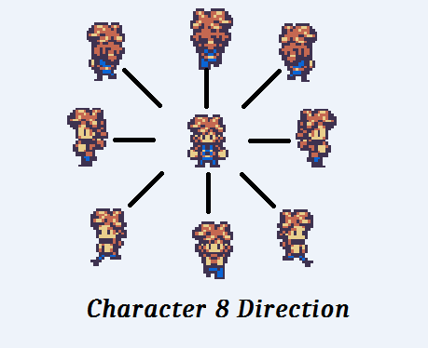

Figure23:Character in8 directions

### Enemies

Theyhavetwo animationstates:idlestate,attackstate. Initiallyenemies’animationstateisidle, if player enters in their inhabitant area the enemies’ state transition to attack state. This mechanism applies to all of the enemies.

### NPCs

TheNPCs onlyhaveoneanimation state, which isidle.

### Environment

Fewofthegameobjectsthatwereusedtodesignenvironmenthaveanimationswhichonlyhave a single state. The following game objects have animations in them

* + - * River:Ithastheriver waveanimationwhichcanbeseeninDungeon_1 scene.
      * WaterFountain:It haswaterflowinganimation whichcan beseen inDungeon_1 scene.
      * Lava:Ithaslavawaveanimationwhich canbeseeninDungeon_2,Dungeon_3 scene.
      * Water:Ithaswaterwave animationwhichcanbeseeninDungeon_2scene.
      * FireTorch:Ithas firemovement animationwhichcanbeseen in allof thedungeons.
      * HealingFountain:Ithas waterflowinganimationwhichcanbeseeninDungeon_1scene.

### UI

There are animation transitions to show the different UI panels, and all of were animated in Unityandhavetwoanimationsstates:“Hide”and “Show”.Hidesimplyhidesthepanelbyeither fade in transition or moving the panel to out of the screen space and show animation does the opposite of hide animation.

## Audio

The following table shows the list of audio clips with description I have used to develop this game,eachoftheaudioclipsmayplayinseveral objectslikesameaudioclipisbeingplayedin several enemies, but I have changed the pitch of the audio clip to distinguish sound effect for enemies.

|  |  |  |
| --- | --- | --- |
| Name | Category | Description |
| Auvic-HealMe | BackgroundMusic | Playsduringthegame |
| Brainwave-Contingency Of  Pink | BackgroundMusic | Playsduringthegame |
| GlitchHopAuvicft.Pipo  Fernandez-Indignation | BackgroundMusic  BackgroundMusic | Playsduringthegame |
| OrangeWolke-Stephen'sTiny  Cafe | BackgroundMusic | Playsduringthegame |
| Thaehan-Pixelated | BackgroundMusic | Playsduringthegame |
| Wontolla-UpToNoGood | BackgroundMusic | Playsduringthegame |
| Shurk-Haunted (JNATHYN  Remix) | BackgroundMusic | Playsduringthegame |
| SGV-Lighthearted | BackgroundMusic | Playsduringthegame |
| OddChap-Midnight Sway | BackgroundMusic | Playsduringthegame |
| game-over-arcade | FX | Playswhentheplayergetsdefeated |
| lemonjolly_hurt4-unh | FX | Playswhenplayergets hurt |
| littlerobotsoundfactory_gate- open | FX | Playswhengatesorbarrieropens |
| musiclegendslaser-shoot | FX | Playswhenplayershootswiththegun, Flame Thrower. |
| jeckkechprojectile | FX | Playswhenplayershootswiththegun,  Canon. |
| cabled-messlaser-shots | FX | Playswhenplayershootswiththegun, MG or Spazer. |
| shoot1 | FX | Playswhenplayershootswiththegun,  MatterorRocket. |

|  |  |  |
| --- | --- | --- |
| shoot_laser | FX | Playswhenplayershootswiththegunor  laser. |
| shoot3 | FX | Playswhenplayershootswiththegun,  Pistolor shotgun. |
| littlerobotsoundfactoryjingle-  achievement-00-victory | FX | Playswhenplayercompletesthelevel. |
| littlerobotsoundfactorypickup-  gold-02 | FX | Playswhenplayerreceivesgoldfrom  chest. |
| syseqgood |  | Playerswhenplayerreceivesweapon from  chest. |
| newagesoupfun-explosion | FX | Playswhenenemydies. |
| BittenVonKrumpen_Hurt | FX | PlayswhentheenemyDevil/Bitten Von  Krumpengetshurt. |
| sharesynth hurt02 | FX | Plays when the enemy imp / Swampy/ MaskedOrc/Wogol/Muddy/Zombie/Orc Shaman/ Skelet/ Slime/ IceZombie gets  hurt. |
| Boss_impact4 | FX | PlayswhentheenemyBigZombie/Ogre/  Minotaur/OneEye/BigDemongetshurt. |
| robotlike_monster_impact3 | FX | PlayswhentheenemyChort/gets hurt. |
| small_monster_impact2 | FX | PlayswhentheenemyTinyZombie/  OrcWarrior/Muddygetshurt. |

Table4:Listof AudioClips withdescriptions

## Attemptstomakegamemorefun

Although common mechanics can make the game functional but that’s not enough for entertainment purpose, to entertain the users we need to pay attention to other parts of the game. With keeping that mind set I have included the following features in the game to make the more fun.

* **Screen Shake:** When player shoots the camera is slightly shaking that gives an impression that an event is occurring.
* **Environment Animations:** I have added river wave, lava, water wave, background animations to make the game visually more beautiful.
* **Background Music:** Instead of playing a single BG music I have added multiple BG music that we usually get to hear in car racing with the order being totallyrandomized.
* **Sound Effects:** Instead of playing same sound clip when player is shooting, I have added different sound clips for each of them, which helps us to distinguish the weapons,andaddedothersoundseffectsthat havebeenplayingasplayerhurt,enemy hurt, victory, game over clip.
* **Character Color Change:** Just hurt sound clip being played does not entirely indicatethecharactergothurtbecauseyoucannottellwhogothurtthatiswhy

changingthe colorcomes in handyin minimal gameslikethis and Iimplemented that as well.

* **Explosion effect:** Just destroying the bullets when come in contact seems static and looks bad that is why adding a simple explosion effect makes a lot difference.
* **Shootingeffect:**Addingaweapontrigger effectalsomakes alot difference.
* **Enemy death effect:** A simple death effect instead of enemy vanishing suddenly outspokenly better.
* **Enemy health bar:** Previously my demo version had no health bar and when my supervisor was trying the demo version, he could not see the progress of hitting enemies which is universal for all the gamers, if there are no health bar for the enemies wecannot tell ifwearereallydamagingtheenemy, thus added enemyhealth bar in my current version.
* **PopupText:**This isamusthavefeatureforallthe2DRPG games,andthusaddedin my game.
* **Toast Message:** Popup text can be used to in various places to inform the player butit is not a good approach to use for the important things like when game ends a text pop up that level is completed but that does not sound rewarded enough so I have added toast message for the special events like level completion, character selection, new weapon reception.

# Chapter7–UserInterface

## :SelectorUnlockCharacterSkinMenuinMainMenu

Inthismenuplayercanunlocknewskin, ifnotsimplyselectthe available playerskin.

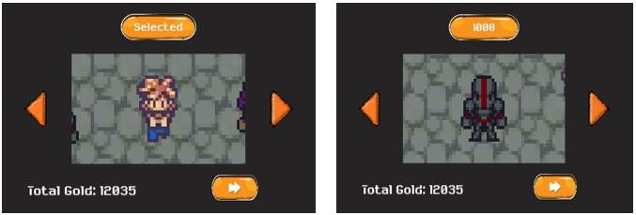

Figure24:Select orUnlockCharacterSkininMain Menu

## :CharacterMenuinGameScenes

Inthismenuplayercanseparatelyupgradeweapons,unlocknewskinwithgold,alsocansee his/her stats.

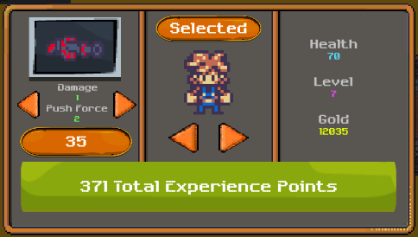

Figure25:Character MenuinGame Scenes

## :PauseMenu

Pause menu simply pauses the game from which we can continue or reply the game, can also go back to menu scene.

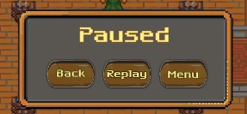

Figure26:PauseMenu

## :DeathMenu

FromDeathMenutheplayercanrestartgameor cangobacktomainmenu.

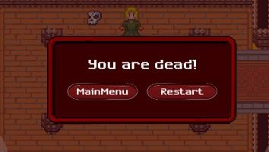

Figure27:Death Menu

## NPCDialogue Box

NPC Dialogue Box shows what’s the NPC wants to sayto the player and has continue button on it for the player to end the conversation.

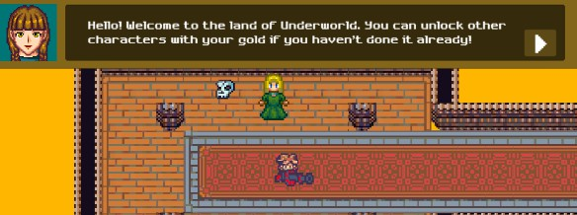

Figure28: NPCDialogueBox

# Chapter8–Conclusion

In this game, I have implemented character unlock and selection system, achievable weaponsanditsindividualweaponupgradesystem,player experience gainingsystem,various typesofAI enemies with different behavior and activities with following theidea of OOP, player and enemy receiving damage system, player reward system, added different effects to most of the player’s intractable objects and also added animations to all of the possible game objects including the user interface.

This game is solely made for the user’s entertainment purpose and its principle objective was to make a game that is similar to old Pixel Art RPG games but yet to have modern vibe.

## FuturePlans

This game is made for PC and Android at the present. There are many scopes available for the improvement of this game including the additions of other functionalities.

Someofthe plans forthefutureof this applicationcould possibly be:

* + - Tomakean IOSversion.
    - TochangethegameartentirelysincefornowI’musingfreeassetstodesignthe levels.
    - Toaddmoredungeonsandincreaseplayer grade’ssystem.
    - Addmoredifferent enemies in thegame
    - Addingmissiongiver NPCS.
    - Addingpet thatfollows theplayer and helphim/herin thecombat.

# Bibliography

1. 0x72. (2018). 16x16 DungeonTileset II. Available from: <https://0x72.itch.io/dungeontileset-ii>[Accessedon20November2018]
2. 0x72. (2018).16x16 DungeonTileset. Available from: <https://0x72.itch.io/16x16-dungeon-tileset>[Accessedon20November2018]
3. FinalBossBlues. (2018). Pixel Shooter and Towers Asset Pack. Available from: <https://finalbossblues.itch.io/pixel-shooter-towers-asset-pack>[Accessedon20November 2018]
4. FinalBossBlues. (2018). Dark Dimension Tileset. Available from: <https://finalbossblues.itch.io/dark-dimension-tileset>[Accessedon25December2018]
5. DragonDePlatino. (2014). DawnLike. Available from: <https://opengameart.org/content/dawnlike-16x16-universal-rogue-like-tileset-v181>[Accessed on 20 December 2018]
6. Manveru.(2014).Minotaur.Availablefrom:

<https://opengameart.org/content/minotaur-0>[Accessedon15December2018]

1. Spring. (2018). 4-Color Assortment. Available from: <https://opengameart.org/content/4-color-assortment>[Accessedon15December2018]
2. Cabbit. (2014). 24x32 Characters Big Pack. Available from: <https://opengameart.org/content/24x32-characters-with-faces-big-pack>[Accessedon15 December 2018]
3. Beast. (2011). Sewer Tileset. Available from: [https://opengameart.org/content/sewer-tileset[Accessedon15December2018]](https://opengameart.org/content/sewer-tileset)
4. Angelee. (2018). Little Servant Devil Animation. Available from: <https://opengameart.org/content/little-servant-devil-animation>[Accessedon15December 2018]
5. C Tatz. (2014). Free UI Asset Pack 1. Available from: <https://opengameart.org/content/free-ui-asset-pack-1>[Accessedon30December2018]
6. Kenney.(2014).OnscreenControls(8styles).Availablefrom:

<https://opengameart.org/content/onscreen-controls-8-styles>[Accessedon30December2018]

1. Buch. (2013). Golden UI – Bigger Than Ever Edition. Available from: <https://opengameart.org/content/golden-ui-bigger-than-ever-edition>[Accessedon30 December 2018]
2. Raluca. (2016). Agile Game Development – A Quick Overview. <https://marionettestudio.com/agile-game-development-quick-overview>[Accessedon 18 November 2018]
3. Auvic - Heal Me [Background Music]. Available from: <https://www.youtube.com/watch?v=vkSP1pNpfEQ>[Accessedon25December2018]
4. Brainwave - Contingency Of Pink [Background Music]. <https://www.youtube.com/watch?v=tfBA1YHp28Q>[Accessedon25December2018]
5. Auvic ft. Pipo Fernandez – Indignation [Background Music]. <https://www.youtube.com/watch?v=k_U_YjFWov8>[Accessedon25December2018]
6. Odd Chap - Midnight Sway [Background Music]. <https://www.youtube.com/watch?v=GHhndFASKxA>[Accessedon25December2018]
7. Orange Wolke - Stephen's Tiny Café [Background Music]. Available from: <https://www.youtube.com/watch?v=0mJo9C_WdrQ>[Accessedon25December2018]
8. SGV – Lighthearted [Background Music]. Available from: <https://www.youtube.com/watch?v=CUT6YOFueIU>[Accessedon25December2018]
9. Shurk - Haunted (JNATHYN Remix) [Background Music]. Available from: [https://www.youtube.com/watch?v=qxLqqiE-334.](https://www.youtube.com/watch?v=qxLqqiE-334)[Accessedon25December2018]
10. Thaehan– Pixelated [Background Music]. Available from: [https://www.youtube.com/watch?v=JWBFq5Bevfk,](https://www.youtube.com/watch?v=JWBFq5Bevfk)[Accessedon25December2018]
11. Wontolla - Up To No Good [Background Music]. Available from: [https://www.youtube.com/watch?v=P5y4T0y_DdE.](https://www.youtube.com/watch?v=P5y4T0y_DdE)[Accessedon25December2018]
12. GameObjects’SoundClips.RetrievedSoundClipsfromFreeSound:[https://freesound.org](https://freesound.org/) [Accessed on 20 December 2018]
13. UnityDocumentation.<https://docs.unity3d.com/ScriptReference>
14. UnityAnswers.[https://answers.unity.com](https://answers.unity.com/)
15. StackOverflow.[https://stackoverflow.com](https://stackoverflow.com/)
16. UMLClassDiagram.RetrievedClassDiagramsfromLucidchart: <https://www.lucidchart.com/pages/uml-class-diagram>